1. You can save all these option settings in some configuration file.
2. 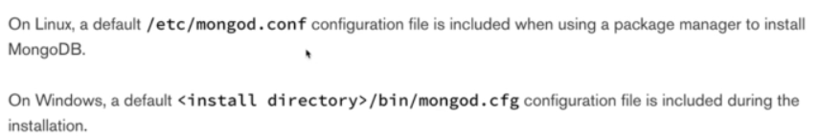
3. 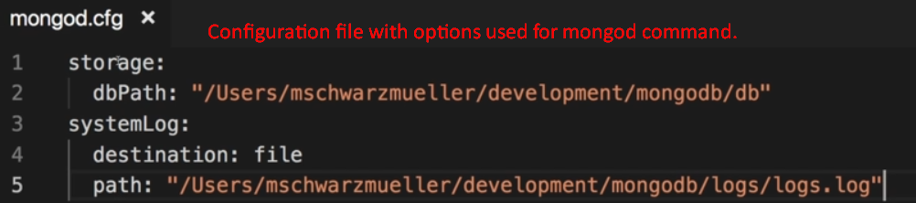
4. 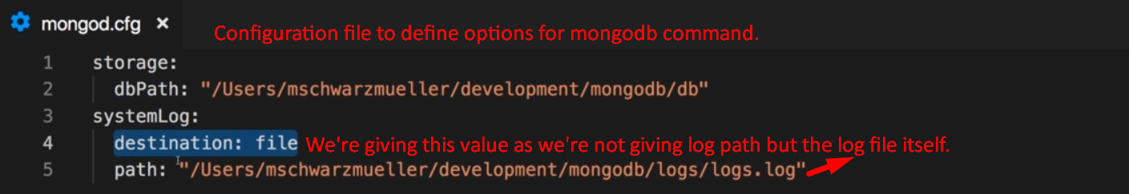
5. 